1)

# Script to create simple menus and take action according to that selected

# menu item

#

while :

do

clear

echo "-------------------------------------"

echo " Main Menu "

echo "-------------------------------------"

echo "[1] Show Todays date/time"

echo "[2] Show files in current directory"

echo "[3] Show calendar"

echo "[4] Start editor to write letters"

echo "[5] Exit/Stop"

echo "======================="

echo -n "Enter your menu choice [1-5]: "

read yourch

case $yourch in

1) echo "Today is `date` , press a key. . ." ; read ;;

2) echo "Files in `pwd`" ; ls -l ; echo "Press a key. . ." ; read ;;

3) cal ; echo "Press a key. . ." ; read ;;

4) vi ;;

5) exit 0 ;;

*) echo "Opps!!! Please select choice 1,2,3,4, or 5";

echo "Press a key. . ." ; read ;;

esac

done

OUTPUT:

# C:\Users\kalburga\Pictures\Screenshots\Screenshot (287).png

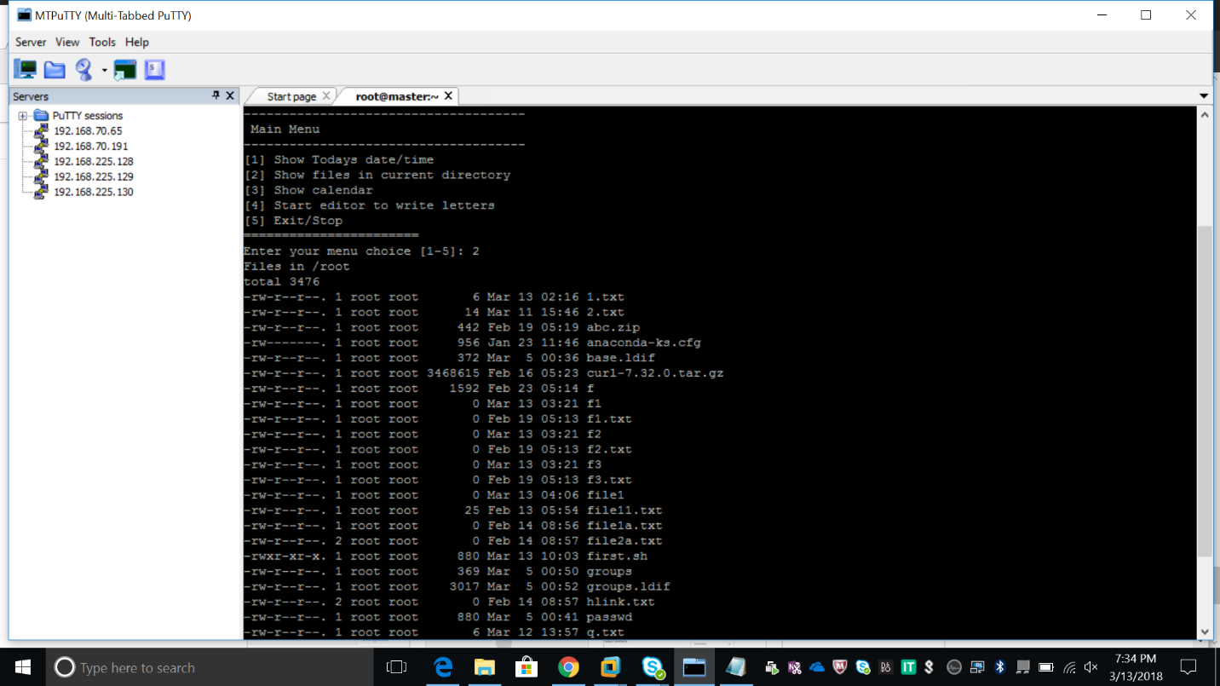

2)

#script to display weedays using for loop

i=1

for day

do

echo "Weekday $((i++)) : $day"

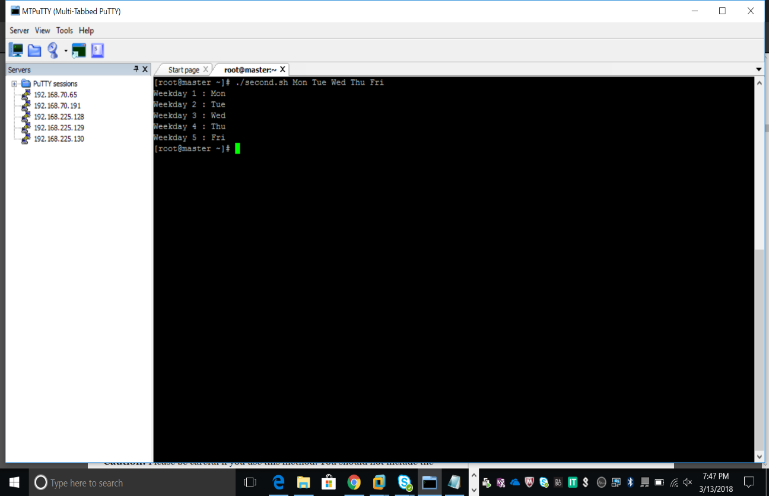done

3)

# script to display all users using the awk command and for loop

i=1

for username in `awk -F: '{print $1}' /etc/passwd`

do

echo "Username $((i++)) : $username"

done

OUTPUT:

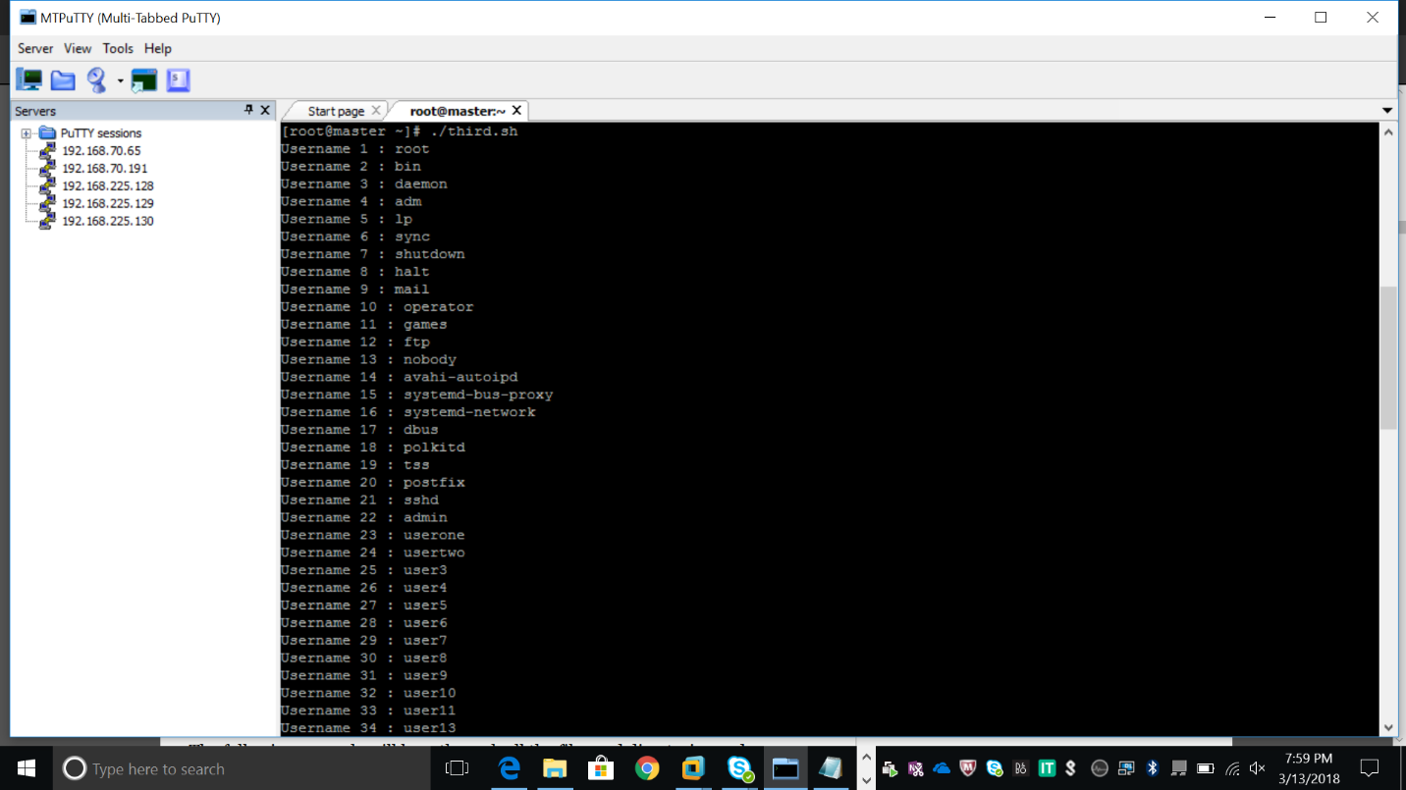

4)#script to allow the following:

# if you are 18 or over you may go to the party. If you aren't but you have a letter from your #parents you may go but must be back before midnight. Otherwise you cannot go.

#!usr/bin/bash

*# elif statements*

if [ $1 -ge 18 ]

then

echo You may go to the party.

elif [ $2 == 'yes' ]

then

echo You may go to the party but be back before midnight.

else

echo You may not go to the party.

fi

OUTPUT:

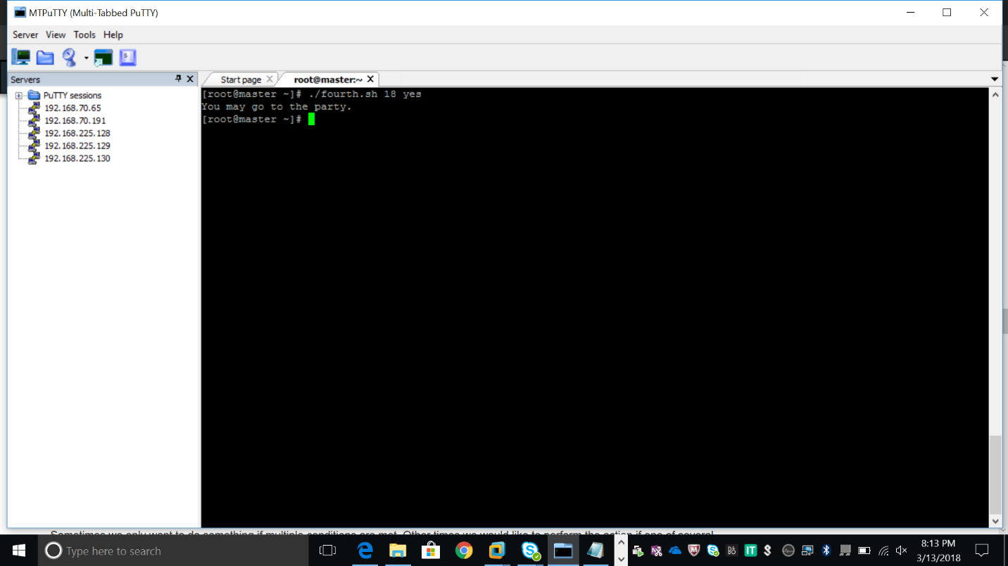

5)

#script to test bash arithmetics

#!usr/bin/bash  
   
echo '### let ###'  
# bash addition  
let ADDITION=3+5  
echo "3 + 5 =" $ADDITION  
  
# bash subtraction  
let SUBTRACTION=7-8  
echo "7 - 8 =" $SUBTRACTION   
  
# bash multiplication  
let MULTIPLICATION=5*8  
echo "5 * 8 =" $MULTIPLICATION  
  
# bash division  
let DIVISION=4/2  
echo "4 / 2 =" $DIVISION  
  
# bash modulus  
let MODULUS=9%4  
echo "9 % 4 =" $MODULUS  
  
# bash power of two  
let POWEROFTWO=2**2  
echo "2 ^ 2 =" $POWEROFTWO  
  
  
echo '### Bash Arithmetic Expansion ###'  
# There are two formats for arithmetic expansion: $[ expression ]   
# and $(( expression #)) its your choice which you use  
  
echo 4 + 5 = $((4 + 5))  
echo 7 - 7 = $[ 7 - 7 ]  
echo 4 x 6 = $((3 * 2))  
echo 6 / 3 = $((6 / 3))  
echo 8 % 7 = $((8 % 7))  
echo 2 ^ 8 = $[ 2 ** 8 ]  
  
  
echo '### Declare ###'  
  
echo -e "Please enter two numbers \c"  
# read user input  
read num1 num2  
declare -i result  
result=$num1+$num2  
echo "Result is:$result "  
  
# bash convert binary number 10001  
result=2#10001  
echo $result  
  
# bash convert octal number 16  
result=8#16  
echo $result  
  
# bash convert hex number 0xE6A  
result=16#E6A  
echo $result

OUTPUT:

